This is a pack of Persona 5 icons that I’ve found across the internet. This document is to instruct you on how to set these icons on your Android device.

**NOTE: This method ONLY works for Android. I do not know how to do this on iOS**

**I also have not kept track on who made these icons, so if you have made them and have proof that you did, contact me and I’ll add credit at the top of this document**

Device Used: Samsung Galaxy S8

Android Version: Android Version 9/Pie

* Download **Nova Launcher** on the Google Play store. Make sure to set it up as your default launcher when prompted to.

This won’t permanently change your phone, you can opt out of the launcher as long as you keep track of where you put the app.

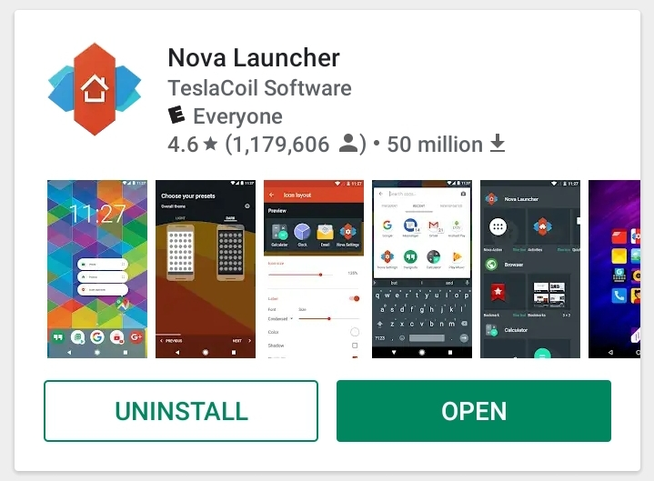

* Once the launcher is set up and you’ve changed some settings to your liking. Now you’re able to **hold down on icons** of your apps. **Holding down** on your icons will allow you to access this submenu. Pressing **Edit** will allow you to access the **Edit App** settings.

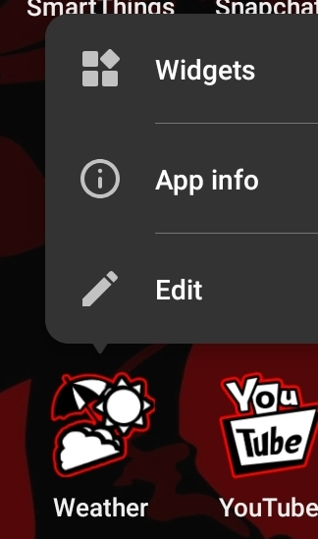

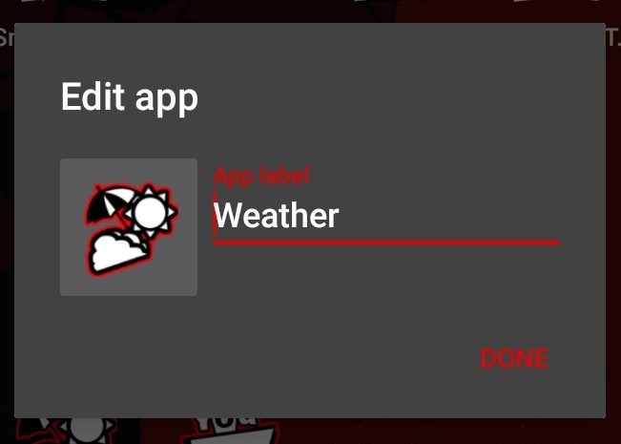

* Here, you’re able to edit the name of the app as well as the icon by **tapping** on the icon in the left of the **Edit App** menu. Tapping this will lead you to another menu, where you have to press **Gallery Apps**.
* Pressing that will allow you to choose where you want your image to come from. I’d suggest keeping the icons saved to your Gallery.

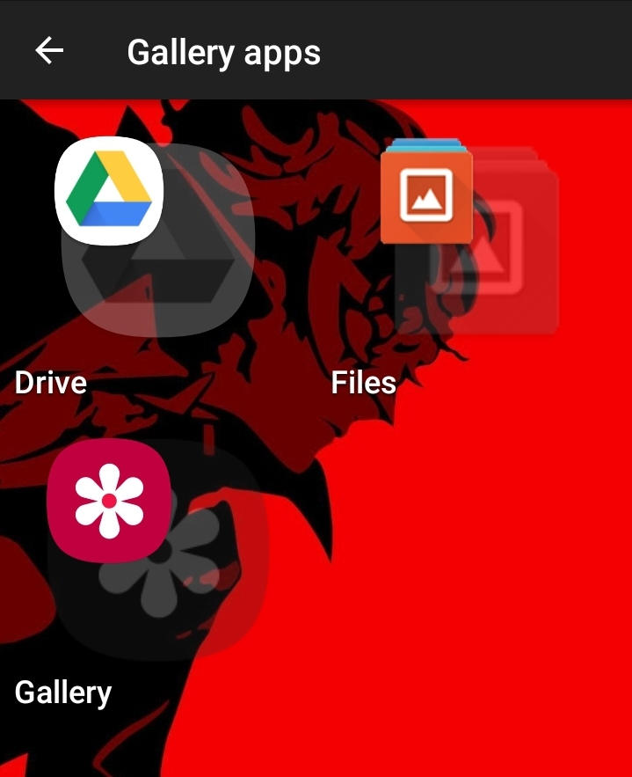

* From here on out, it’s pretty straight forward. You can just select any image and you’re done editing the icon!

If you have any further questions/unclear stuff, feel free to contact me and I’ll do my best to answer your question.

**NOTE: Changing icons on your home screen/app drawer does NOT change them in your notification bar or any other places.**

**Bonus points if you are on a Samsung device, you can get a Red Theme in the Themes section.**